1. ex3-0



#!/bin/bash

echo "hello world"

2. ex3-1

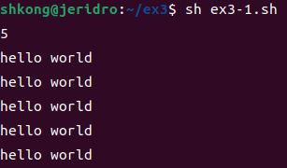

#!/bin/bash

read var

for i in `seq $var`

do

echo "hello world"

done

3. ex3-2

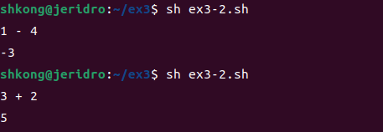

#!/bin/bash

read num1 var num2

case $var in

+ )

echo "$(expr $num1 + $num2)"

;;

- )

echo "$(expr $num1 - $num2)"

;;

esac

4. ex3-3

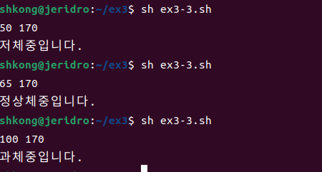

#!/bin/bash

read weight height

bmi=`echo "scale=3; $weight/($height\*$height\*0.01\*0.01)" |bc -l`

ra=18.5

rb=23

if [ $(echo "scale=1; $bmi < $ra" | bc) -ne 0 ]

then

echo "저체중입니다.";

elif [ $(echo "scale=1; $bmi >= $rb" | bc) -ne 0 ]

then

echo "과체중입니다.";

else

echo "정상체중입니다.";

fi

5. ex3-4

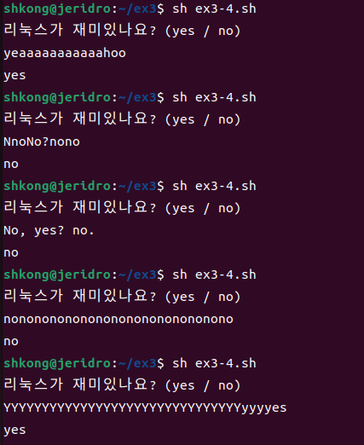

#!/bin/bash

echo "리눅스가 재미있나요? (yes / no)";

read yn

case $yn in [yY]\*)

echo "yes";;

[nN]\*)

echo "no";;

\*)

echo "yes or no로 입력해주세요."

exit 1;;

esac

exit 0

6. ex3-5

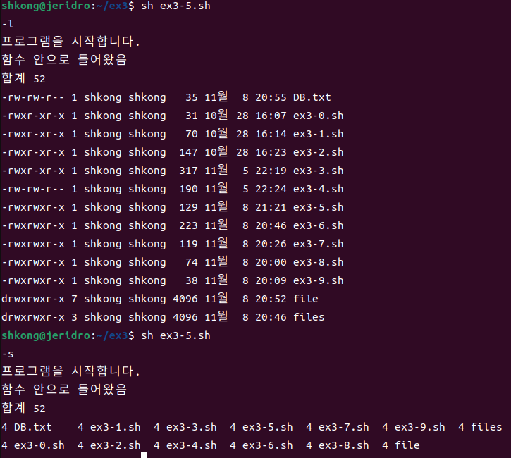

#!/bin/bash

function() {

echo "함수 안으로 들어왔음"

ls $a

}

read a

echo "프로그램을 시작합니다."

function $a

7. ex3-6

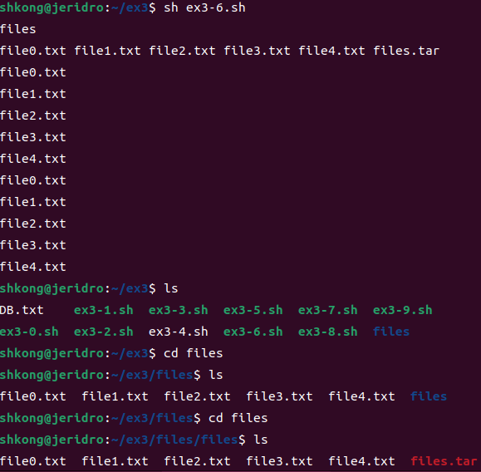

#!/bin/bash

read dir

mkdir -p $dir

cd $dir

read n1 n2 n3 n4 n5 n6

touch $n1

touch $n2

touch $n3

touch $n4

touch $n5

touch $n6

tar cvf $n6 $n1 $n2 $n3 $n4 $n5

mkdir $dir

mv $n6 /home/shkong/ex3/$dir/$dir

cd $dir

tar xvf $n6

8. ex3-7

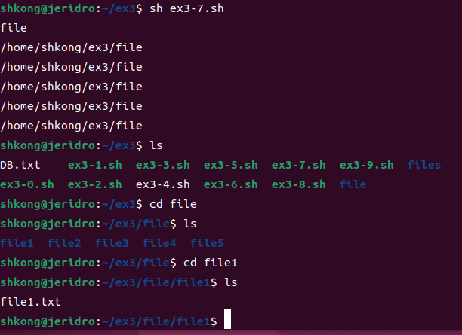

#!/bin/bash

read name

mkdir $name

cd $name

for i in 1 2 3 4 5

do

mkdir $name$i

cd $name$i

touch $name$i.txt

cd -

done

9. ex3-8

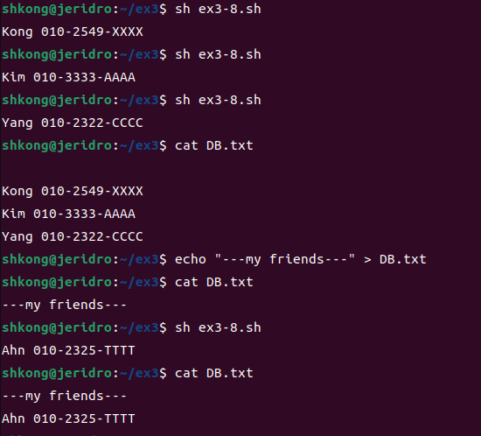

#!/bin/bash

touch DB.txt

read info

touch DB.txt

echo "$info" >> DB.txt

10. ex3-9

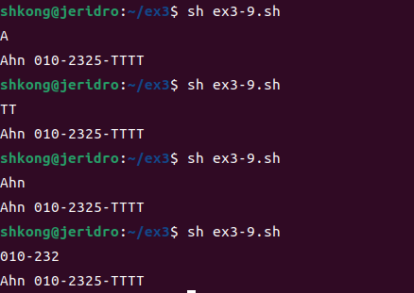

#!/bin/bash

read a

grep -i $a DB.txt